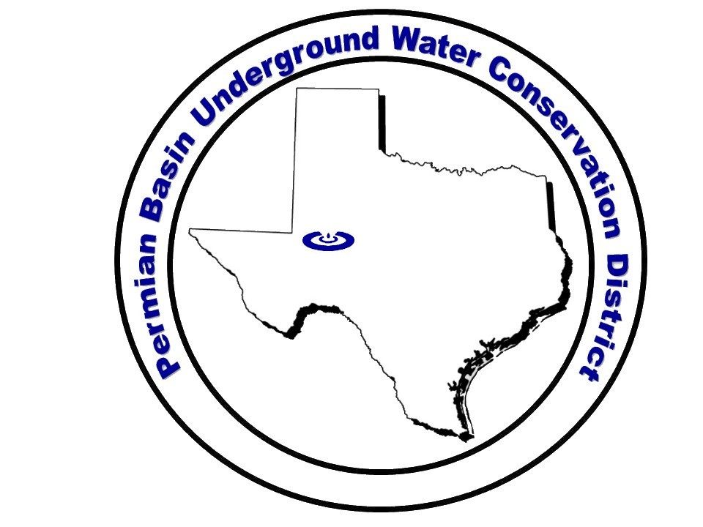
Directors
John F. Campbell, President
Lloyd Robinson, Vice-President
Christopher Stone, Secretary
Raymond Straub Jr.
Tex Edwards

General Manager
Leatrice Adams
101 N St. Joseph · P.O. Box 1314 · Stanton, Texas 79782
Bus: (432) 756-2136 · Fax: (432) 756-2068
E-mail: permianbasin@sbcglobal.net
www.pbuwcd.com
Permian Basin Underground
Water Conservation District
Directors
John F. Campbell, President
Lloyd Robinson, Vice-President
Christopher Stone, Secretary
Raymond Straub Jr.
Tex Edwards

General Manager
Leatrice Adams
101 N St. Joseph · P.O. Box 1314 · Stanton, Texas 79782
Bus: (432) 756-2136 · Fax: (432) 756-2068
E-mail: permianbasin@sbcglobal.net
www.pbuwcd.com
Permian Basin Underground
Water Conservation District
Directors
John F. Campbell, President
Lloyd Robinson, Vice-President
Christopher Stone, Secretary
Raymond Straub Jr.
Tex Edwards

General Manager
Leatrice Adams
101 N St. Joseph · P.O. Box 1314 · Stanton, Texas 79782
Bus: (432) 756-2136 · Fax: (432) 756-2068
E-mail: permianbasin@sbcglobal.net
www.pbuwcd.com
Permian Basin Underground
Water Conservation District
Directors
Richie Tubb, President
Raymond Straub Jr., Vice Pres.
Brad Tunnell
Brandon Borgstedt
Kristopher Alles

General Manager
Angela Lance
Permian Basin Underground
Water Conservation District

708 W. St. Peter · P.O. Box 1314 · Stanton, Texas 79782
Bus: (432) 756-2136 · Fax: (432) 756-2068
E-mail: permianbasin@pbuwcd.com
www.pbuwcd.com

Information Required by Section 26.18, Texas Tax Code
Date: April 4, 2025

1. The name of each member of the governing body of the taxing unit:

President – Richie Tubb
Vice-President – Raymond Straub, Jr.
Secretary – Brad Tunnell
Brandon Borgstedt
Kristopher Alles

2. The mailing address, e-mail address, and telephone number of the taxing unit:

PO Box 1314
Stanton, Texas 79782
Email: permianbasin@pbuwcd.com
Phone: (432) 756-2136
Facsimile: (432) 756-2068

3. The official contact information for each member of the governing body of the taxing unit, if that information is different from the information described in Subdivision (2):

Same as Item (2)

4. The taxing unit’s budget for the preceding two years:

Oct ’22 – Sept ’23 Approved Budget

 | Income |  | 2022-2023
 |  | 400 – Interest Revenue | $0.00
 |  | 401 – Martin County | $369,799.46
 |  | 402 – Howard County | $130,123.00
Total Income |  |  | $499,922.46
 | Expense
 |  | 440 – Purchased Services | -
 |  | 440.01 – Auditor | $9,000.00
 |  | 440.02 – Legal Services | $15,000.00
 |  | 440.03 – Martin CAD Fees | $1,500.00
 |  | 440.04 – Howard CAD Fees | $3,000.00
 |  | 440.05 – Insurance – Liability | $4,500.00
 |  | 440.06 – Insurance – Property | $5,000.00
 |  | 440.07 – Insurance – Workman’s Comp | $2,300.00
 |  | 440.08 – Maintenance | $10,000.00
 |  | 440.09 – Telephone & Internet | $13,000.00
 |  | 440.10 – Contracted Services | $27,166.74
 |  | 440.11 – Utilities | $8,000.00
 |  | 440.12 – Lab Services | $1,500.00
 |  | Total 440 – Purchased Services | $99,966.74
 |  | 450 – Salaries and Benefits | $289,696.52
 |  | 460 – Supplies | $11,700.00
 |  | 470 – Other Expenditures | -
 |  | 470.01 – Bank Fees | $300.00
 |  | 470.02 – Dues & Subscriptions | $3,000.00
 |  | 470.03 – Education & Public Relations | $15,000.00
 |  | 470.04 – Travel | $4,000.00
 |  | 470.05 – Vehicle & Maintenance | $7,000.00
 |  | 470.07 – Miscellaneous | $405.70
 |  | Total 470 – Other Expenditures | $29,705.70
 |  | 480 – Capital Outlay | $257,655.00
Total Expense |  |  | $688,723.96
Oct ’23 – Sept ’24 Amended Budget

 | Income |  | 2023-2024
 |  | 400 – Interest Revenue | $42,468.47
 |  | 401 – Martin County | $386,868.43
 |  | 402 – Howard County | $122,591.16
Total Income |  |  | $551,928.06
 | Expense
 |  | 440 – Purchased Services | -
 |  | 440.01 – Auditor | $9,500.00
 |  | 440.02 – Legal Services | $39,529.89
 |  | 440.03 – Martin CAD Fees | $929.57
 |  | 440.04 – Howard CAD Fees | $1,228.00
 |  | 440.05 – Insurance – Liability | $4,125.96
 |  | 440.06 – Insurance – Property | $3,746.54
 |  | 440.07 – Insurance – Workman’s Comp | $1,388.62
 |  | 440.08 – Maintenance | $9,353.53
 |  | 440.09 – Telephone & Internet | $18,101.10
 |  | 440.10 – Contracted Services | $44,364.48
 |  | 440.11 – Utilities | $8,551.00
 |  | 440.12 – Lab Services | $2,173.70
 |  | Total 440 – Purchased Services | $142,992.39
 |  | 450 – Salaries and Benefits | $342,986.82
 |  | 460 – Supplies | $14,749.65
 |  | 470 – Other Expenditures | -
 |  | 470.01 – Bank Fees | $1,560.36
 |  | 470.02 – Dues & Subscriptions | $4,533.13
 |  | 470.03 – Education & Public Relations | $13,897.40
 |  | 470.04 – Travel | $2,117.46
 |  | 470.05 – Vehicle & Maintenance | $10,406.27
 |  | 470.07 – Miscellaneous | $2,769.54
 |  | Total 470 – Other Expenditures | $35,284.16
 |  | 480 – Capital Outlay | $5,399.97
Total Expense |  |  | $541,412.99

5. The taxing unit’s adopted budget for the current year:

Oct ’24 – Sept ’25 Approved Budget
 | Income |  | 2024-2025
 |  | 400 – Interest Revenue | $42,000.00
 |  | 401 – Martin County | $395,000.00
 |  | 402 – Howard County | $145,282.00
Total Income |  |  | $582,282.00
 | Expense
 |  | 440 – Purchased Services | -
 |  | 440.01 – Auditor | $10,000.00
 |  | 440.02 – Legal Services | $50,000.00
 |  | 440.03 – Martin CAD Fees | $1,100.00
 |  | 440.04 – Howard CAD Fees | $1,300.00
 |  | 440.05 – Insurance – Liability | $5,500.00
 |  | 440.06 – Insurance – Property | $4,900.00
 |  | 440.07 – Insurance – Workman’s Comp | $1,500.00
 |  | 440.08 – Maintenance | $5,000.00
 |  | 440.09 – Telephone & Internet | $20,500.00
 |  | 440.10 – Contracted Services | $40,000.00
 |  | 440.11 – Utilities | $9,100.00
 |  | 440.12 – Lab Services | $3,000.00
 |  | Total 440 – Purchased Services | $151,900.00
 |  | 450 – Salaries and Benefits | $355,145.40
 |  | 460 – Supplies | $9,436.60
 |  | 470 – Other Expenditures | -
 |  | 470.01 – Bank Fees | $300.00
 |  | 470.02 – Dues & Subscriptions | $8,000.00
 |  | 470.03 – Education & Public Relations | $18,000.00
 |  | 470.04 – Travel | $7,000.00
 |  | 470.05 – Vehicle & Maintenance | $12,000.00
 |  | 470.07 – Miscellaneous | $3,000.00
 |  | Total 470 – Other Expenditures | $48,300.00
 |  | 480 – Capital Outlay | $17,500.00
Total Expense |  |  | $582,282.00
Net Income |  |  | $0.00

6. The change in the amount of the taxing unit’s budget from the preceding year to the current year, by dollar amount and percentage:
There was an increase in the District’s current budget from the preceding year of $40,869.01 or 7.27%.

7. The amount of property tax revenue budgeted for maintenance and operations for the preceding two years and the current year:
FY2023 $499,924.00
FY2024 $541,412.99
FY2025 $582,282.00

8. The amount of property tax revenue budgeted for debt service for the preceding two years and the current year:
FY 2023 $0
FY 2024 $0
FY 2025 $0

9. The tax rate from maintenance and operations adopted by the taxing unit for the preceding two years:
FY2022-23 $0.001873/$100
FY2023-24 $0.001648/$100

10. The tax rate for debt service adopted for the preceding two years:
FY2023 $0
FY2024 $0

11. The interest and sinking fund rate adopted by the district for the preceding two years:
Applicable only to school districts.

12. The tax rate for maintenance and operations proposed by the taxing unit for the current year:
FY2025 $0.00175035/$100

13. The tax rate for debt service proposed by the taxing unit for the current year:
FY2025 $0

14. The interest and sinking fund tax rate proposed for the current year:
Applicable only to school districts.

15. The most recent financial audit of the taxing unit:
See Annual Financial Report in Website Resources

